1. Get refresh token

python refresh_token.py -c client.json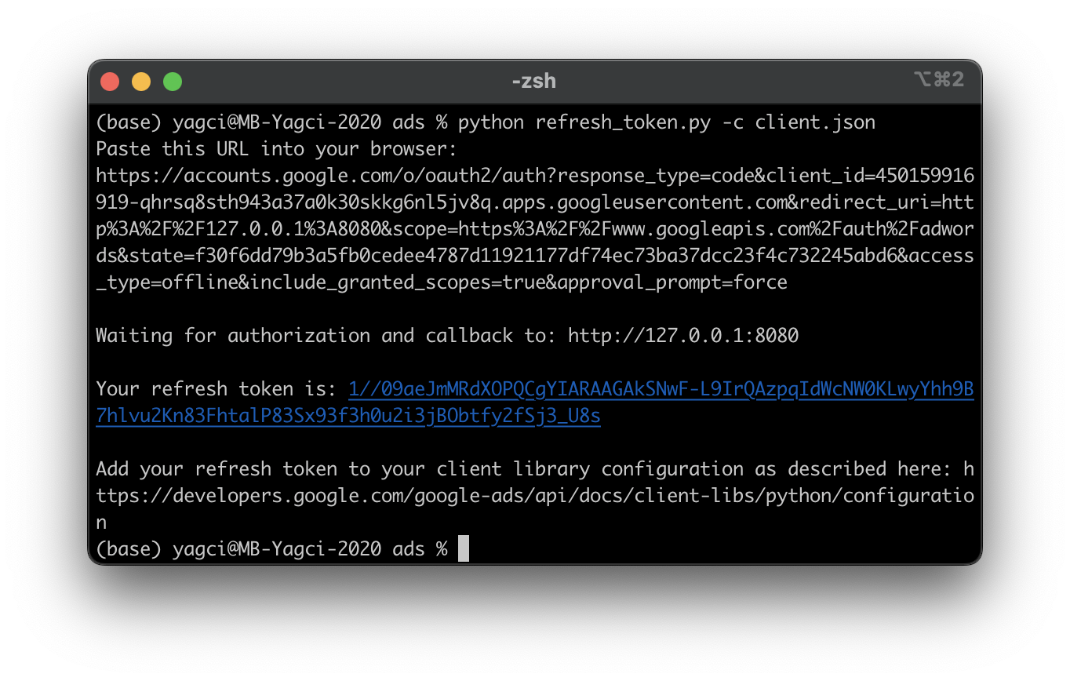

* Open link "https://accounts.google.com/o/auth2/… " in a browser (Hint: Firefox does not work, Safari does, not tested with Chrome).
* Log in to Search Studies Google account and accept oauth (searchstudies.haw@gmail.com, searchstudieshamburg)
* Return to console to get the new refresh token
* Update refresh token in google-ads.yaml file

2. INFO: Google-Ads.yaml

# **GoogleAdsClient will read the google-ads.yaml configuration file in the**

# **home directory if none is specified**.

googleads_client = GoogleAdsClient.load_from_storage(version="v13")

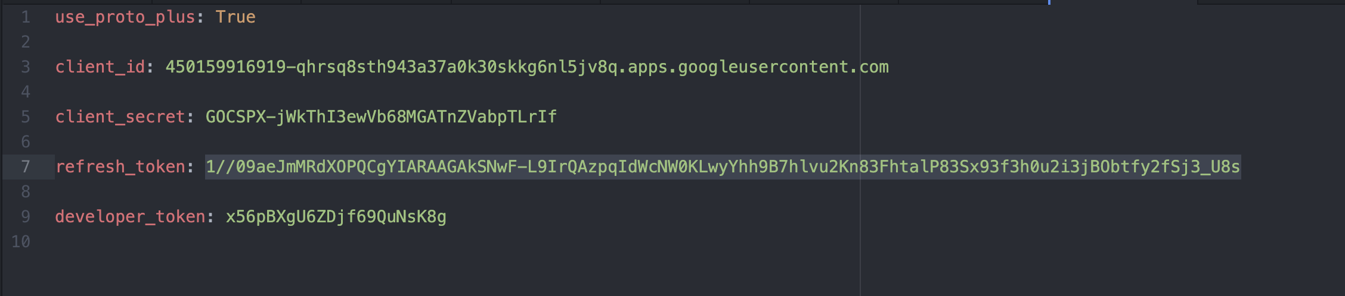

3. Generate keyword ideas

* Run keyword_planner_usage.ipynb to generate keyword ideas.
* keyword_planner.ipynb is the anonymised version, for sharing, _usage contains our client id.
* Follow guidelines in notebook to configure options

4. IF WEB APP BREAKS: Setting up a new web application

* Log into Google Cloud with Search Studies Account
* Create new Project
* Set up OAuth-ClientID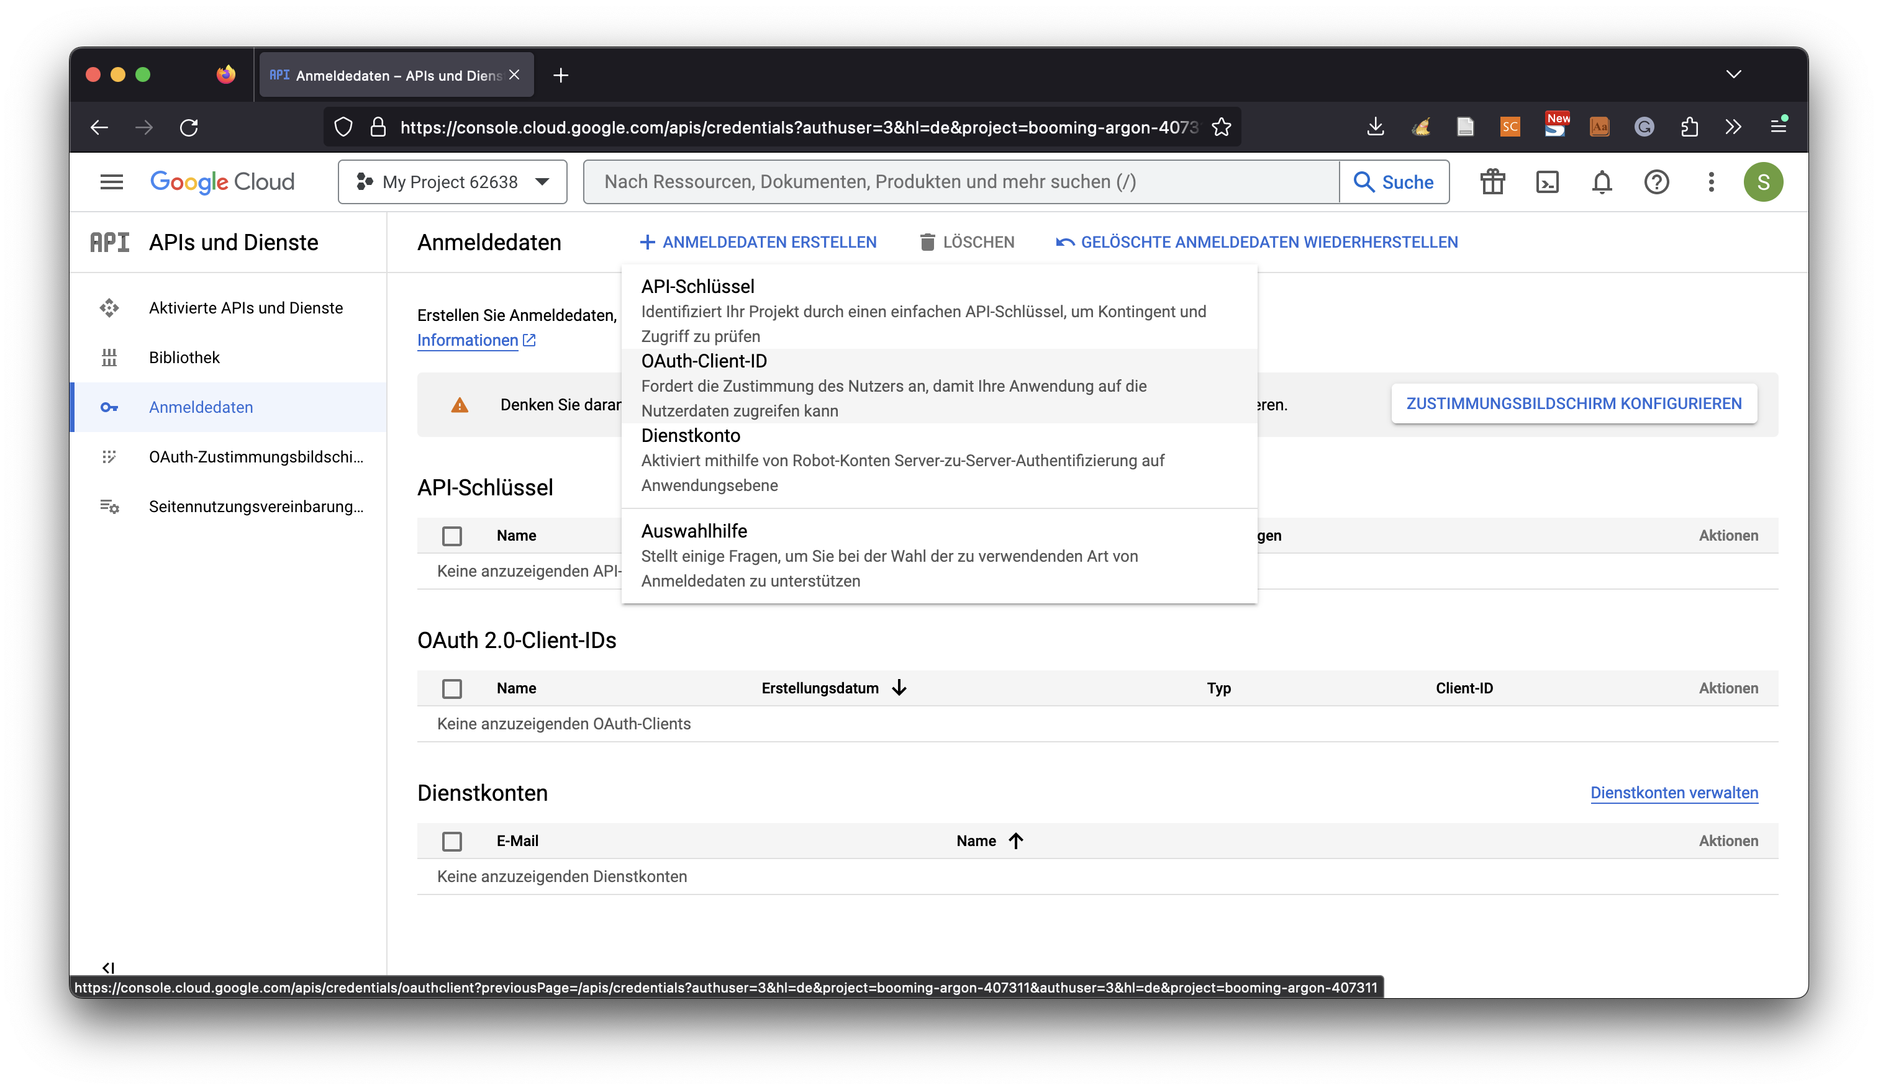
* Create "Webanwendung"
* Add <http://127.0.0.1:8080> to Autorisierte JavaScript-Quellen and Autorisierte Weiterleitungs-URIs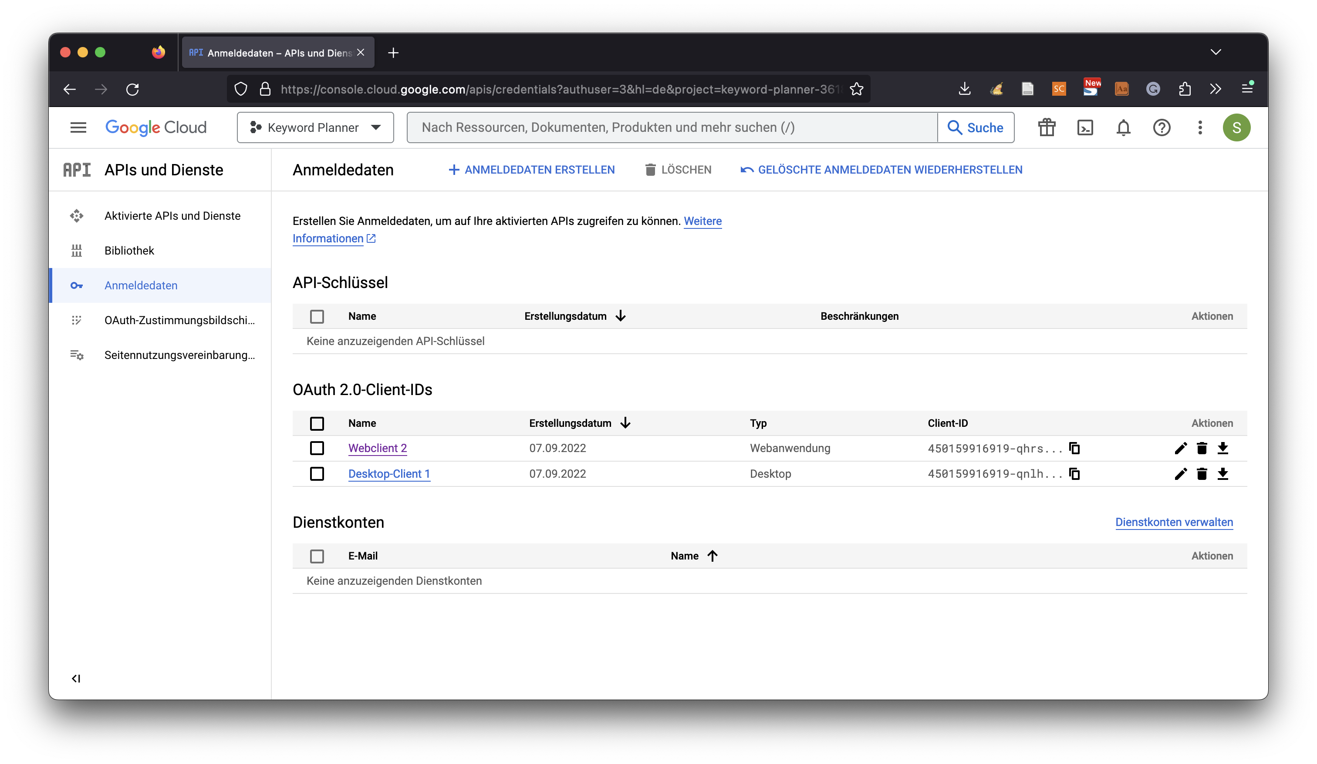
* Download OAuth-Client file to replace old client.json